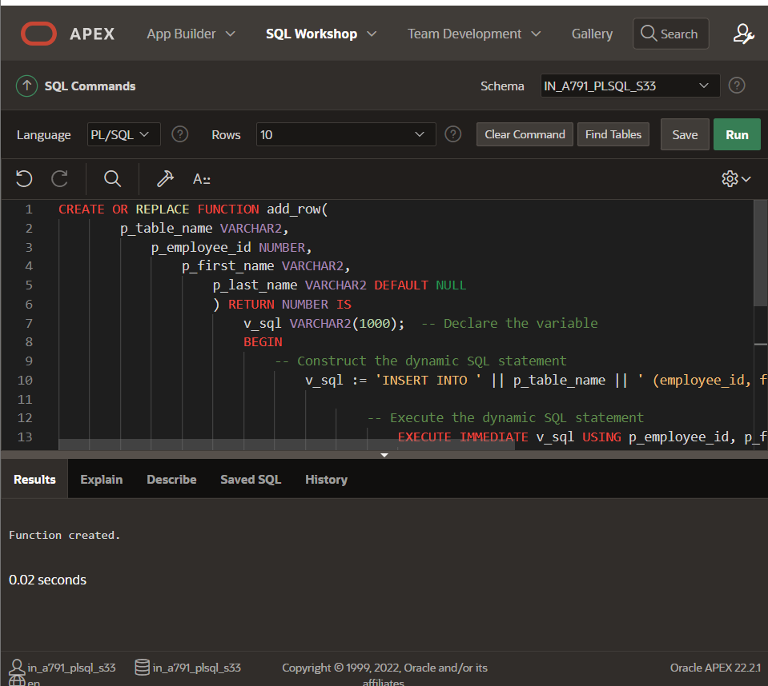

CREATE OR REPLACE FUNCTION add_row(

p_table_name VARCHAR2,

p_employee_id NUMBER,

p_first_name VARCHAR2,

p_last_name VARCHAR2 DEFAULT NULL

) RETURN NUMBER IS

v_sql VARCHAR2(1000); -- Declare the variable

BEGIN

-- Construct the dynamic SQL statement

v_sql := 'INSERT INTO ' || p_table_name || ' (employee_id, first_name, last_name) VALUES (:1, :2, :3)';

-- Execute the dynamic SQL statement

EXECUTE IMMEDIATE v_sql USING p_employee_id, p_first_name, p_last_name;

-- Return the number of rows affected by the SQL statement

RETURN SQL%ROWCOUNT;

END;